BLOOMINGDALE BOUROUGH BOARD OF HEALTH
REGULAR MEETING MINUTES – August 6, 2018

- Call to Order.
Ms. Petersen called the meeting to order at 7:41 p.m.

- Roll Call.
Present: Petersen, Innamorato, Reynolds, Carney and Fallon
Also Present: Peter Correale, Health Officer
Gail Gratzel, Assistant Health Officer

- Approval of Minutes.
Motion was made by Ms. Carney to approve the June 4, 2018 minutes as presented. This motion was seconded by Ms. Innamorato and was unanimously approved.

- Acceptance of Reports
After discussion of the presented reports on motion by Ms. Carney with a second by Ms. Innamorato the Health Department Monthly Report, Retail Food Inspection Summary Report, and Year to Date Report were approved as submitted and unanimously approved.

- Unfinished Business
Mayor’s Wellness Campaign: Ms. Gratzel reported that the Wellness Challenge has been going well. Approximately 177 people registered between the five municipalities. Many people are taking advantage of the free offerings. There is two weeks left for people to participate. The Finale is scheduled for July 21st.
Stigma Free: Ms. Gratzel reported that the Youth Mental Health First Aid Class was held on June 9th and 15 people participated in the class.
Bloomingdale Health Contract: Ms. Petersen will send Mayor Dunleavy an email with regards to the upcoming Pequannock Health Contract. It will be put on next month’s agenda for approval.

- New Business
Mr. Correale updated the board on the status of a new Legionella case at Bloomingdale Health Center. The water samples have been received, with some areas of concern. All shower heads have been fitted with filters and residents/kitchen are using bottled water per Mr. Correale. The health department will continue to follow the case and remediation. Sometimes remediation can take several months to a year. Currently the Bloomingdale Health Center has hired a consultant, water samples have been taken and dead legs in the plumbing are being located and repaired. Next steps would be either super chlorination or heating of all plumbing lines and then resampling.

- Public Discussion
Motion was made by Ms. Carney to open the meeting to public discussion. This motion was seconded by Ms. Fallon and all voted in favor. As there was no public wishing to address the Board, motion was made by Ms. Carney to close the meeting to public discussion. This motion was seconded by Ms. Innamorato and all voted in favor.

- Adjournment
Motion was made by Ms. Innamorato to adjourn the meeting at 8:06 p.m. This motion was seconded by Ms. Fallon and all voted in favor.

Approved:
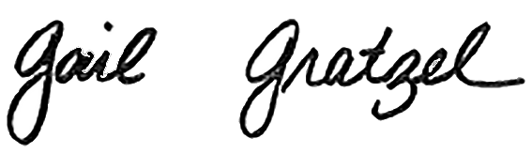
Gail Gratzel, MPH
Assistant Health Officer

